Name : Saqib Shehzad

Reg.No : 2021-CS-187

Query 1 :

select \*

from orders

where ShippedDate >RequiredDate

Output :

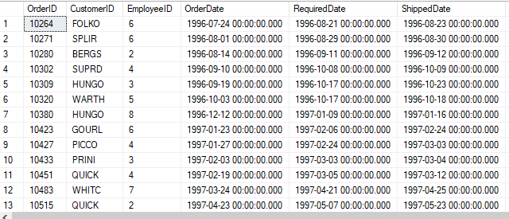

Query 2 :

select Country

from Employees

Output :

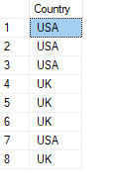

Query 3 :

Not understandable

Output :

Null

Query 4:

select ProductName

From Products

where Discontinued = 1

Output :

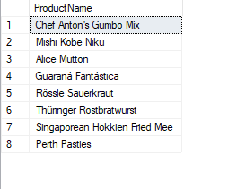

Query 5 :

select OrderID

from [Order Details]

where Discount = 0

Output :

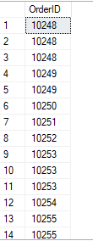

Query 6 :

select CustomerID

from Customers

where Region is NULL

Output :

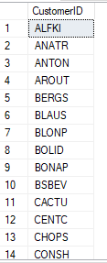

Query 7 :

select CustomerID ,Phone

from Customers

where Country = 'UK' or Country = 'USA'

Output :

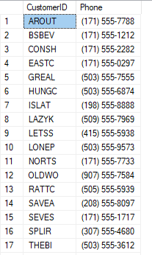

Query 8 :

select CompanyName

from Suppliers

where HomePage is not NULL

Output :

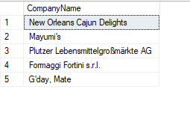

Query 9 :

select ShipCountry

from Orders

where ShippedDate >= 1997-1-1 or ShippedDate <= 1997-12-30

Output :

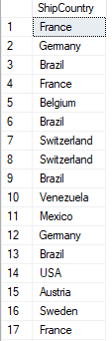

Query 10 :

select CustomerID

from Orders

where ShippedDate is NULL

Output :

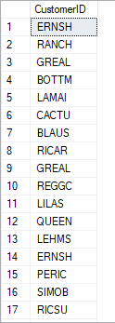

Query 11 :

select SupplierID,CompanyName,City

from Suppliers

Output :

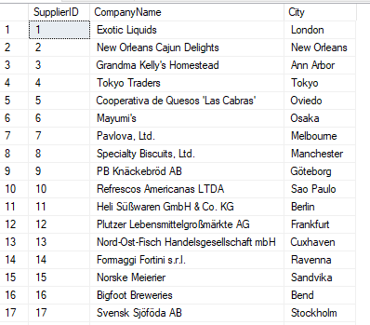

Query 12 :

select \*

from Employees

where City = 'London'

Output :

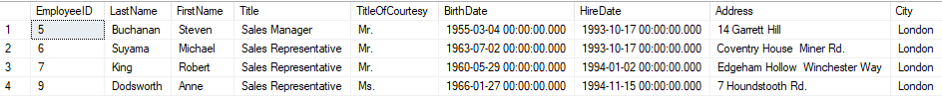

Query 13 :

select ProductName,Discontinued

from Products

where Discontinued =0

Output :

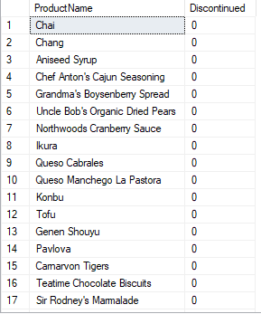

Query 14 :

select OrderID

from [Order Details]

where Discount <= 0.1

Output :

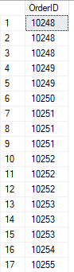

Query 15 :

select EmployeeID,FirstName,HomePhone,Extension

from Employees

where Region is NULL

Output :

